Develop an app using Watson IoT Platform

Bluemix Lab Guide



Experience the power of IBM Bluemix  
Lab 1

*Activity 3: Add Node-RED flow to IoT App*

Activity 3: Add Node-RED flow to IoT App

What is Node-RED? Node-RED is an open-source tool created by the IBM Emerging Technology It provides a browser-based flow editor that makes it easy to wire together devices, APIs, and online services by using the wide range of nodes in the palette. Flows can be then deployed to the Node.js runtime with a single click. Below are available nodes categories you can use to build the flow.

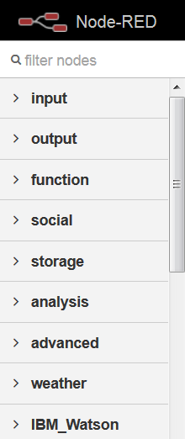

1. Go back to your IoT project in Bluemix by clicking the link on the top left corner.

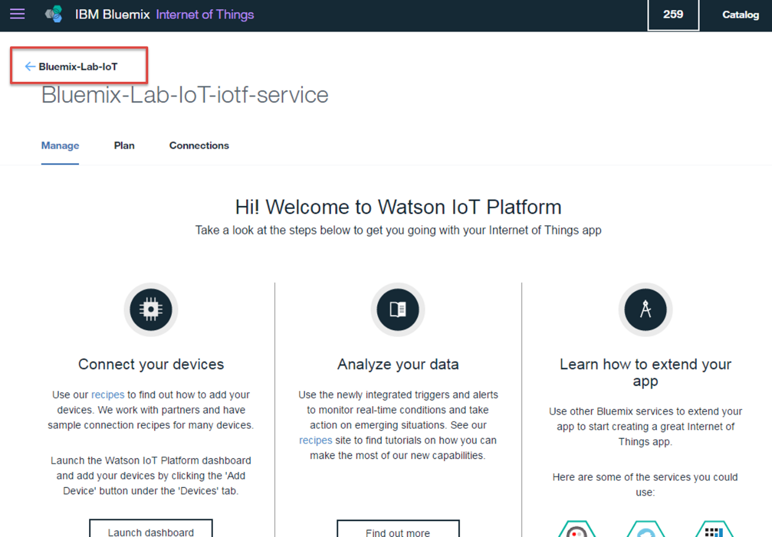

1. Click the “**View App**” buton to access your application and the Node-RED web editor.

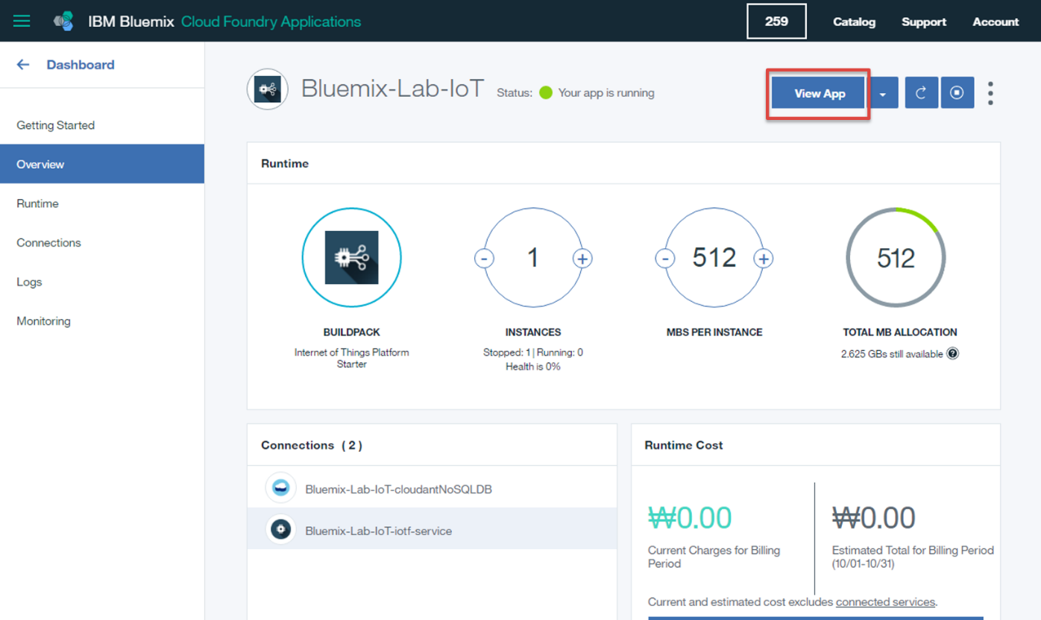

1. Click the “**Go to your Node-RED flow editor**” button.

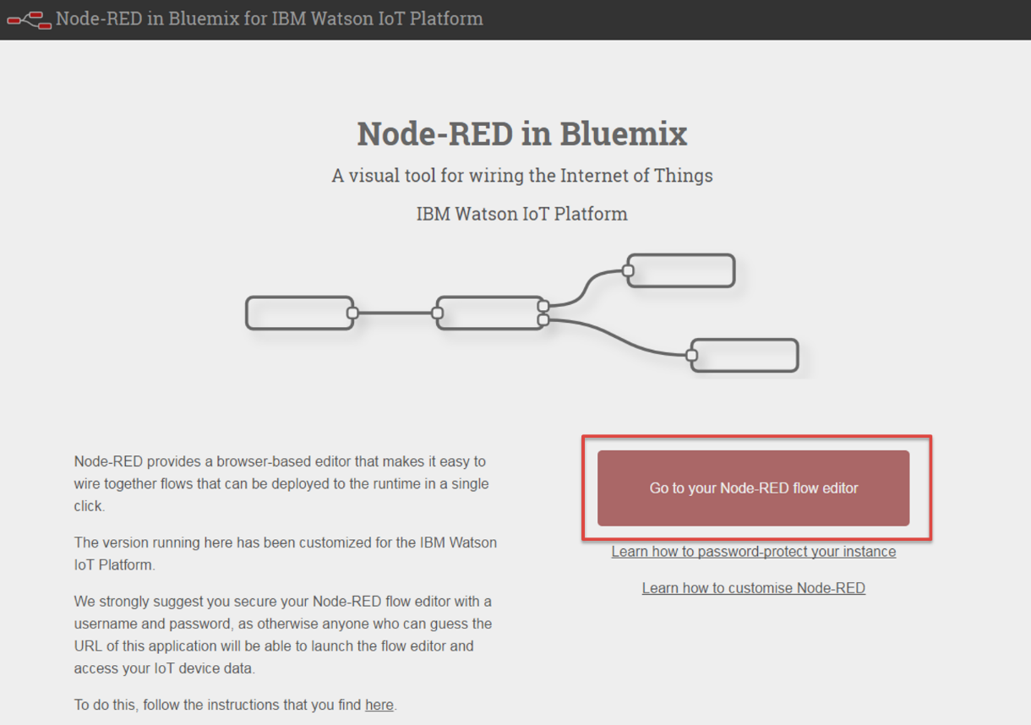

1. First, delete the existing default flow (select the all nodes by dragging your mouse and press the “**Delete**” key on the keyboard).

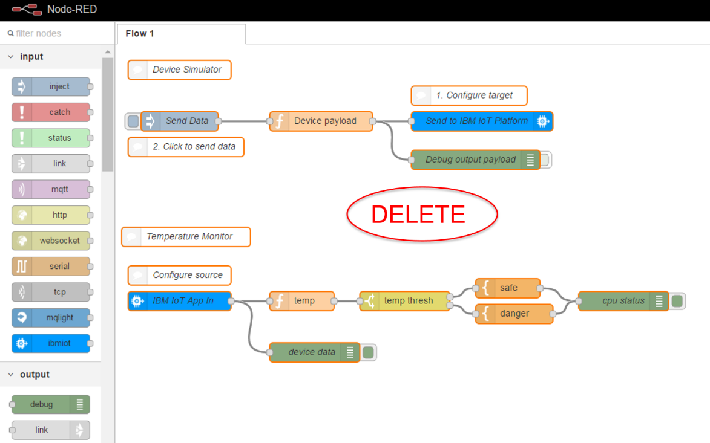

1. Then create a new flow (drag and drop the following nodes):

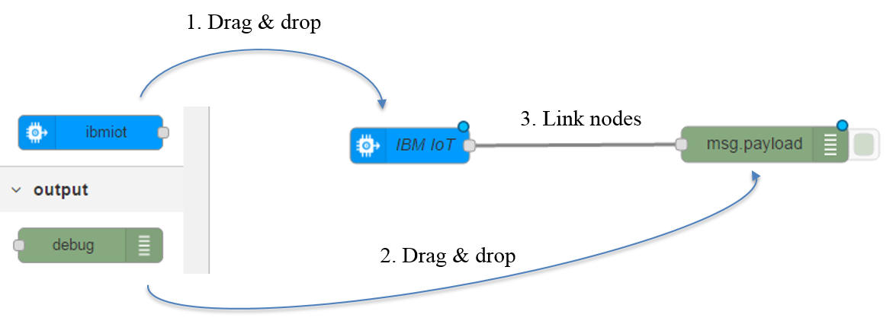

1. Then, double click on the IBM IoT node to configure it with the “Bluemix service” authentication and fill your device id:



1. Click **Done** and deploy your app by clicking on the **Deploy** button (The button on the upper right corner turns grey which means the flow is deployed). Then select the debug tab to visualize your data:



Now you can click on **Activate Sensor** from your mobile app, so your app starts to send messages to the Watson IoT platform.

You are receiving data via MQTT protocol in JSON format which displays in the debug tab and you should also see a “connected” label under the IBM IoT node. Note: if you can’t see the debug tab, make sure to extend your browser window.



1. To stop sending message from smartphone, click on **Deactivate Sensor** from your mobile app.
2. We are going to implement a simple scenario that will switch on/off the light of your smartphone each time you flip it horizontally, using the “light” command.

Go to your Node-RED flow and follow the steps 1), 2) and 3) below. You will create the following flow by drag and dropping the appropriate nodes and wiring them as shown below:

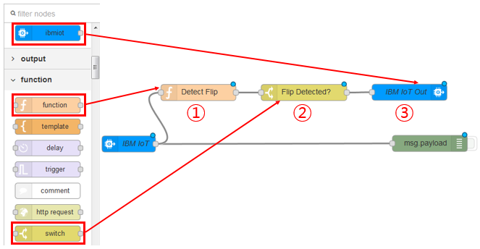

* 1. Drag & drop a “function” node.

In this first box we test the value of the **acceleration_z** from the smartphone to check whether or not this value is positive or negative. Below is the logic that will be coded into the function node:

* if **acceleration_z** is positive
  + if the light is switched ‘OFF’ send “light” command to the phone to switch the light “ON”
* if **acceleration_z** is negative
  + if the light is already switched ‘ON’ send “light” command to the phone to switch the light “OFF”.
* Save the state of the light in a context variable

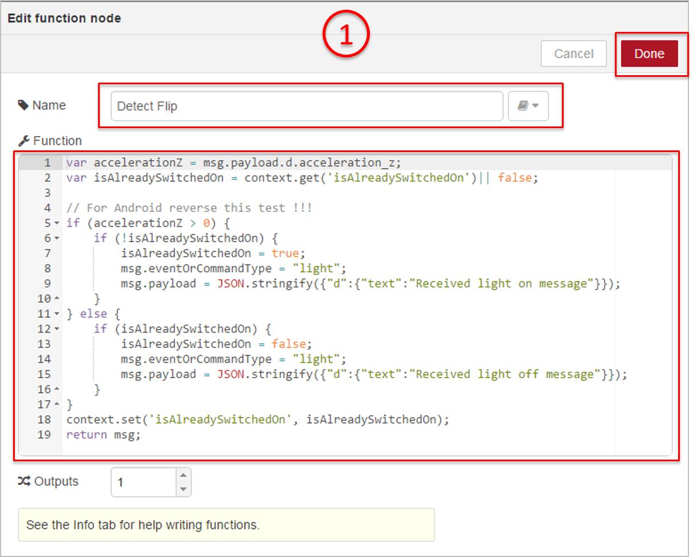

**Code** for cut & paste:

var accelerationZ = msg.payload.d.acceleration_z;

var isAlreadySwitchedOn = context.get('isAlreadySwitchedOn') || false;

// For Android reverse this test !!!

if (accelerationZ > 0) {

if (!isAlreadySwitchedOn) {

isAlreadySwitchedOn = true;

msg.eventOrCommandType = "light";

msg.payload = JSON.stringify({"d":{"text":"Received light on message"}});

}

} else {

if (isAlreadySwitchedOn) {

isAlreadySwitchedOn = false;

msg.eventOrCommandType = "light";

msg.payload = JSON.stringify({"d":{"text":"Received light off message"}});

}

}

context.set('isAlreadySwitchedOn', isAlreadySwitchedOn);

return msg;

* 1. Drag & drop a “switch” node to test whether or not we need to send a command to the phone.

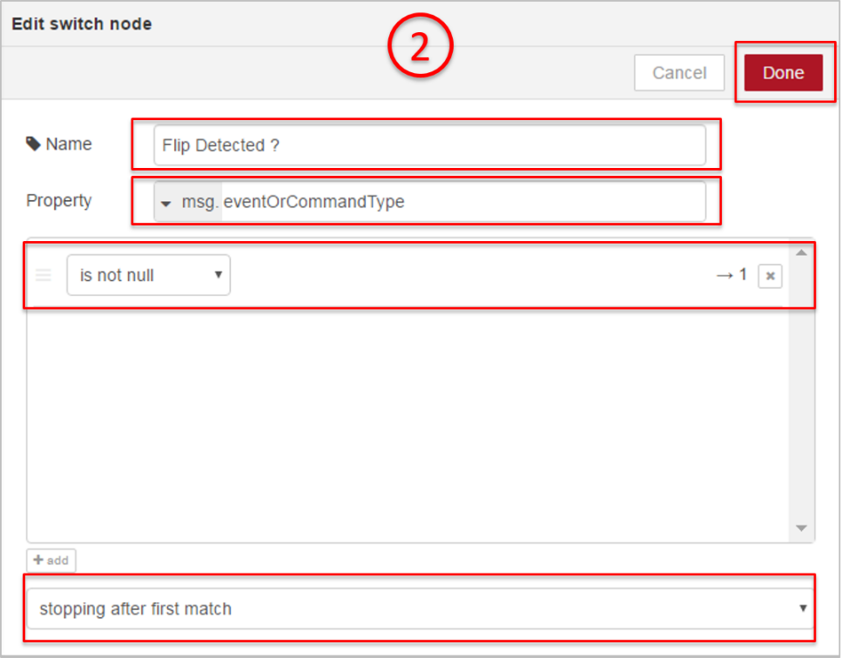

* 1. Drag & drop an “ibmiot out” node to send the “**light**” command to the phone and fill in the fields as shown below.

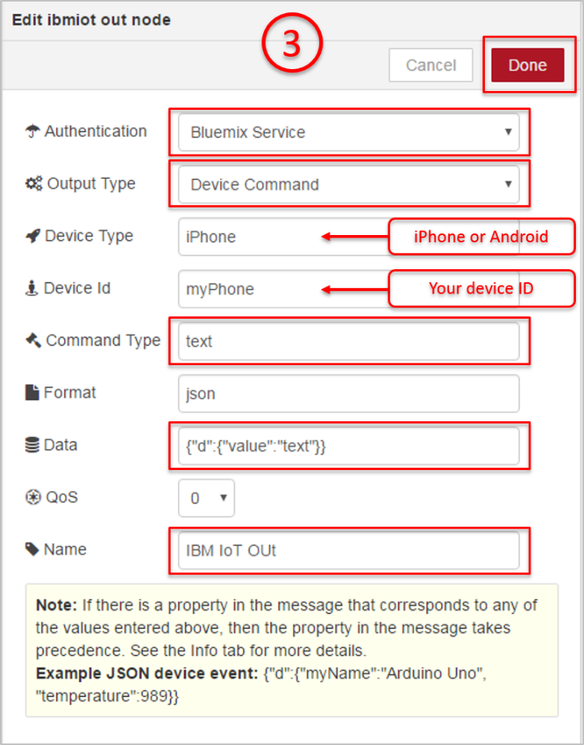

At this stage, deploy your new flow by pressing the “Deploy” button on your upper right screen.

Now, grab your phone, run the IoT Starter App and click on “Activate Sensor”.

* Watch the « Debug » window in Node Red to see the incoming mqtt messages from the phone
* Flip your phone horizontally and check that the light is ON!
* Flip it back and check that the light is back OFF.

To stop sending message from smartphone, click on **Deactivate Sensor** from your mobile app.

**Congratulations! You have just completed the lab 1.**

|  |
| --- |
| **End of Document** |